*Missing uuid*

**36e1864e-0ca2-428c-9f97-3ad124a2e455 33016**

*Actual uuid*

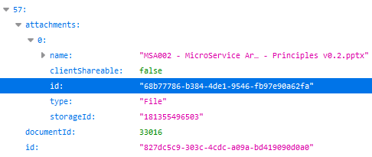

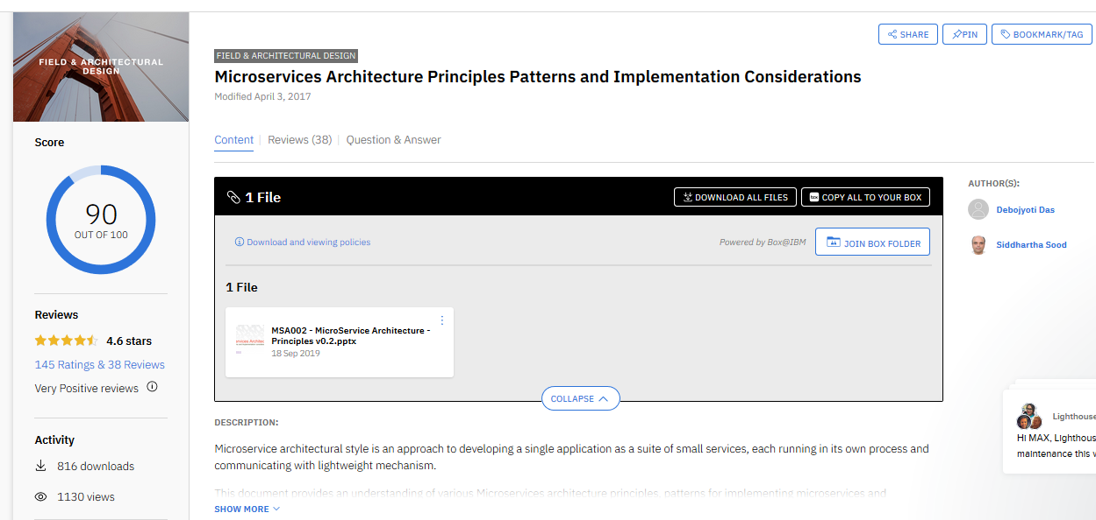

KVS.DOCUMENT_ATTACHMENT table

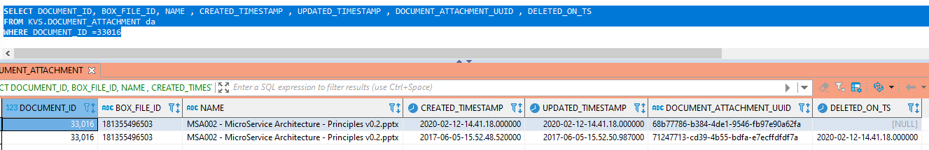

*Missing uuid*

**e7d09bbc-a14c-4d41-af40-c3361cfd7b63 39237**

*Actual uuid*

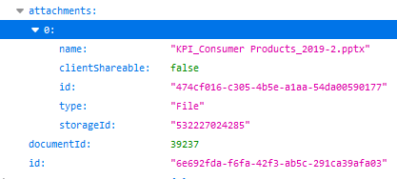

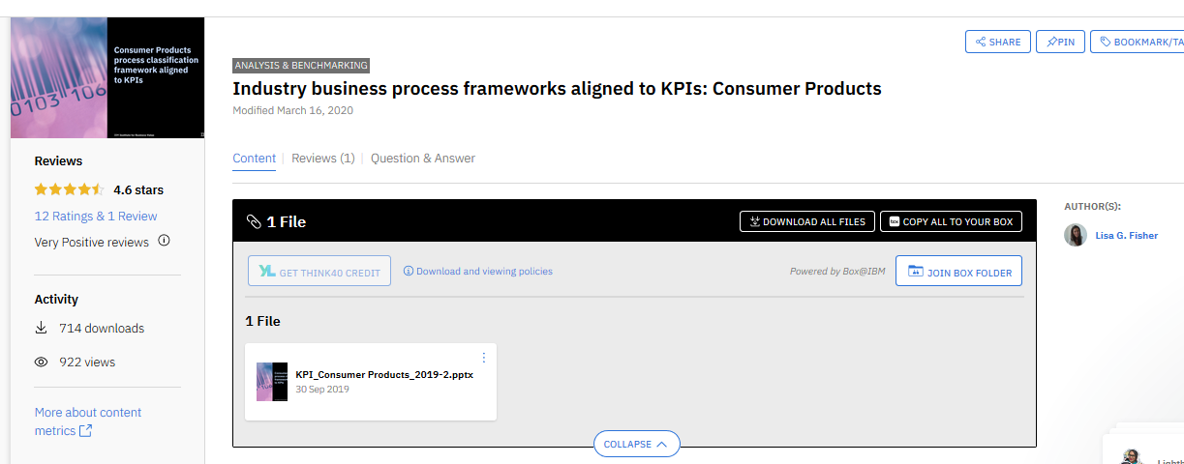

KVS.DOCUMENT_ATTACHMENT table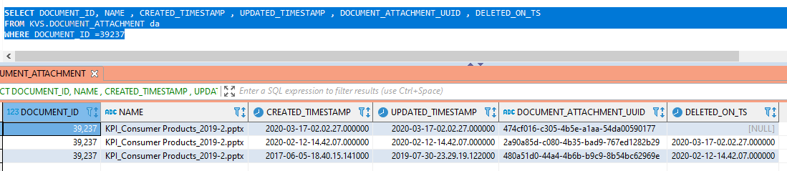

*Missing uuid*

**4d463b68-50d3-436d-a5e3-15271224c24c 39286**

*Actual uuid*

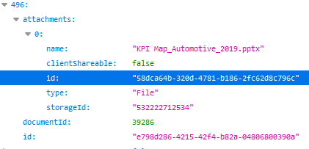

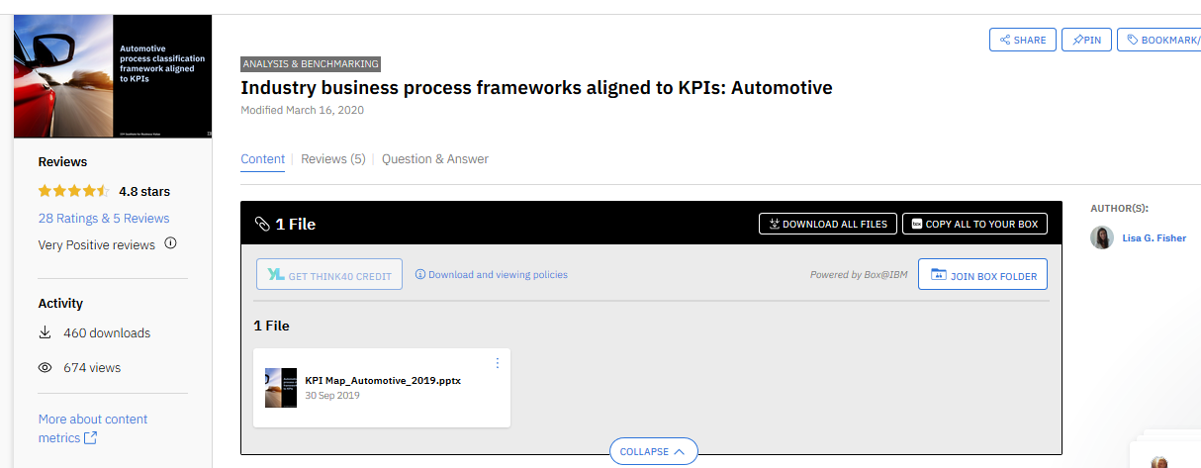

KVS.DOCUMENT_ATTACHMENT table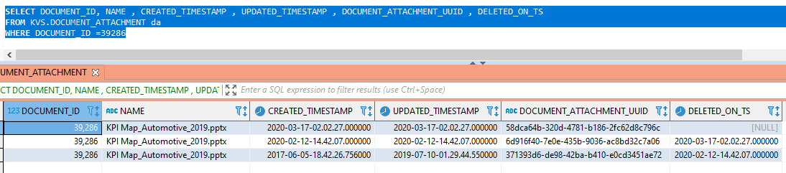

*Missing uuids*

**785503d5-8f2e-4cac-bc71-1c982f3f2de7 39546**

**88a47dac-6680-498b-a4cf-6372068a5ea1 39546**

**95e5a22f-93e9-47cf-9dc2-b98ebf80a51c 39546**

**fb9a4c03-aabd-41d8-9e94-dc60a08c795d 39546**

*Actual uuids*

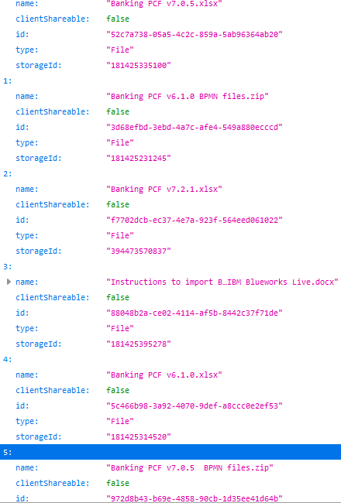

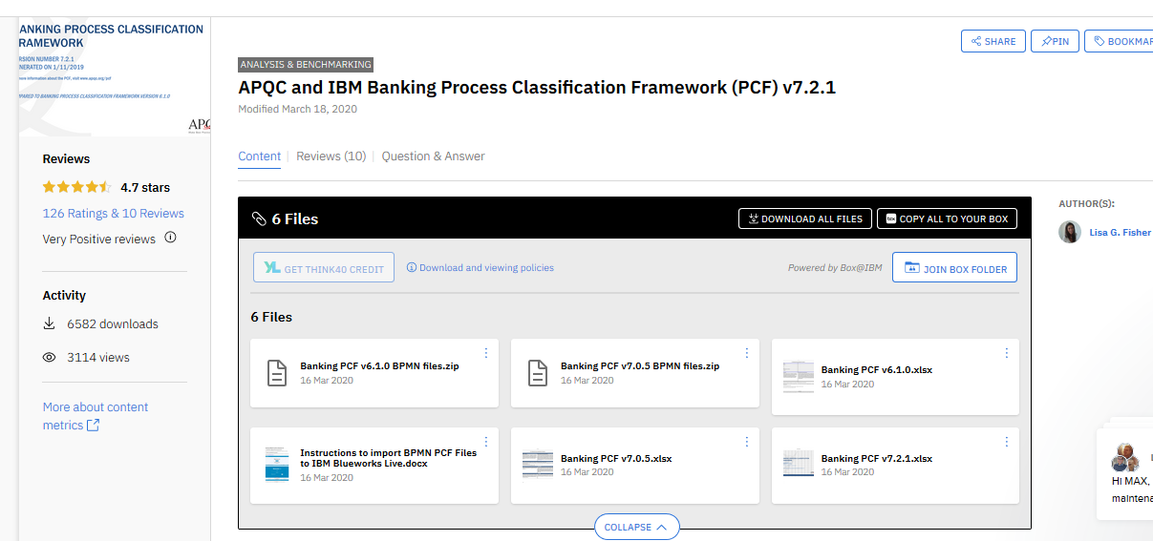

KVS.DOCUMENT_ATTACHMENT table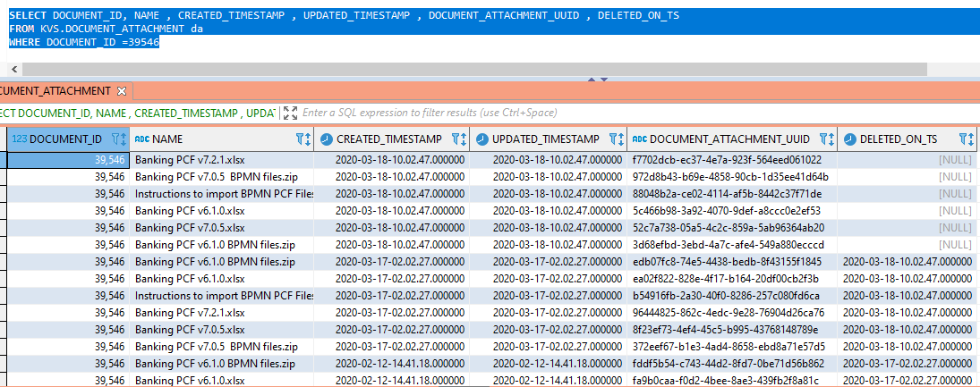

*Missing uuid*

**618a8bb6-37d8-45b6-9a60-39e5bd8c1b68 39551**

**b0681c7b-563a-430b-bff9-6085be2ddb38 39551**

*Actual uuid*

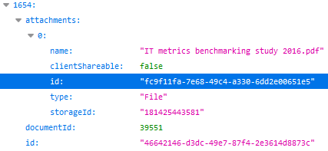

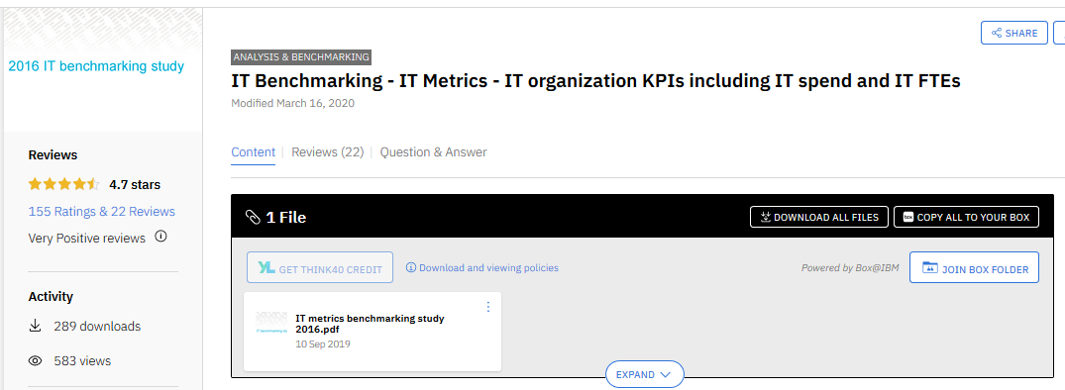

KVS.DOCUMENT_ATTACHMENT table

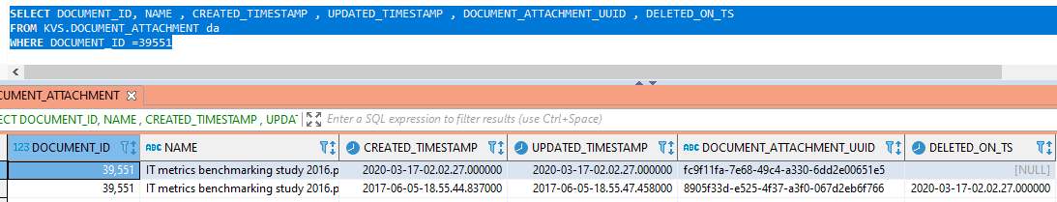

*Missing uuid*

**4d463b68-50d3-436d-a5e3-15271224c24c 39286**

*Actual uuid*





KVS.DOCUMENT_ATTACHMENT table